work on your property contributes to Fire-wise status and fire safety rating!
Firewise
Activity Log

Prepare
your
home

Address or Lot # (or name)

Firewise Activities performed at or around following property. You must submit one for each lot you own.

Activity | Hours
Clearing brush and mowing weeds
Removing low branches or flammable growth
Other fuel reduction
Gutter, screen, roof, or other structure repair
Other
IMPORTANT: Reports
must be received by
October15th to count for this year’s Firewise status.
o
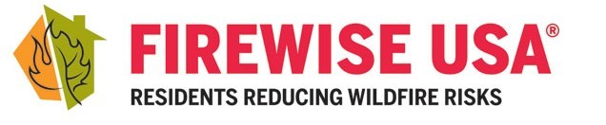
Sunlight Waters Business Office: 150 Clubhouse Rd, Cle Elum, WA 98922

